TASK 3.9

Step 1

**QUERY 1:**

with Top10_country(Country)

as

(select ct.country from customer c

join address a

on c.address_id = a.address_id

join city ci

on a.city_id = ci.city_id

join country ct

on ci.country_id = ct.country_id

group by ct.country

order by count(c.customer_id) desc

limit 10),

Top10_City

as

(select ci.city from customer c

join address a

on c.address_id = a.address_id

join city ci

on a.city_id = ci.city_id

join country ct

on ci.country_id = ct.country_id

where ct.country in (select * from Top10_country )),

Total_amount

as

(select c.customer_id,concat(c.first_name,' ',c.last_name) as customer_name,ct.country,ci.city,sum(p.amount) as Highest_total_amount

from payment p

join customer c

on p.customer_id = c.customer_id

join address a

on c.address_id = a.address_id

join city ci

on a.city_id = ci.city_id

join country ct

on ci.country_id = ct.country_id

where ci.city in

(select * from Top10_city)

GROUP BY c.customer_id,ct.country, ci.city

ORDER BY Highest_total_amount DESC

LIMIT 5)

select avg (Highest_total_amount) as Average

from Total_amount;

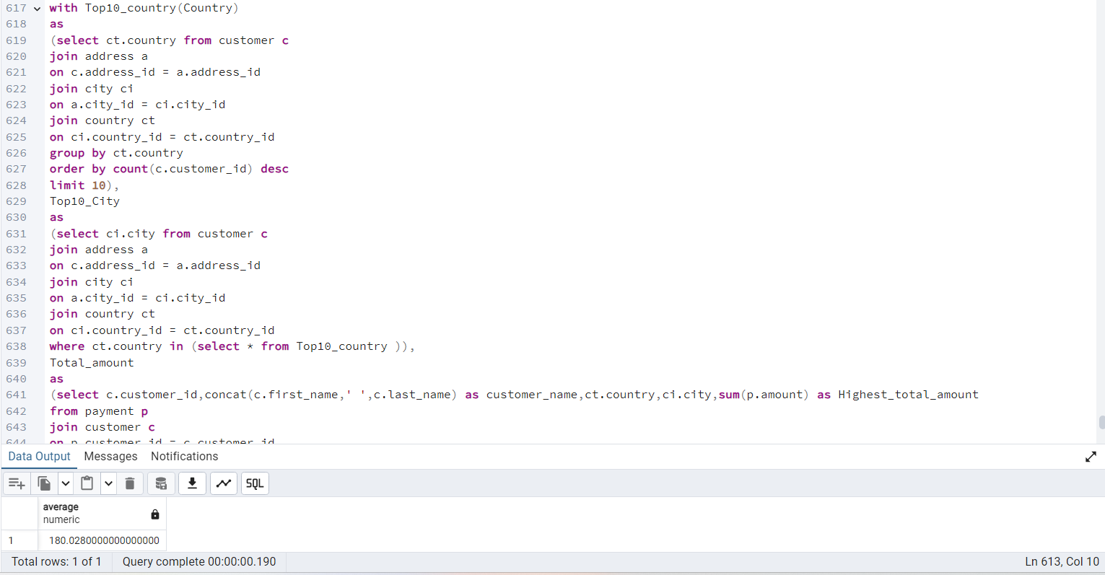

**QUERY 2:**

with Top10_country(Country)

as

(select ct.country from customer c

join address a

on c.address_id = a.address_id

join city ci

on a.city_id = ci.city_id

join country ct

on ci.country_id = ct.country_id

group by ct.country

order by count(c.customer_id) desc

limit 10),

Top10_City

as

(select ci.city from customer c

join address a

on c.address_id = a.address_id

join city ci

on a.city_id = ci.city_id

join country ct

on ci.country_id = ct.country_id

where ct.country in (select * from Top10_country )

group by ct.country, ci.city

order by count(c.customer_id) desc

Limit 10),

total_amount_paid as (

select c.customer_id, ct.country, sum(P.amount) as total_amount_payment

from payment p

inner join customer as c on C.customer_id = P.customer_id

inner join address as a on A.address_id = C.address_id

inner join city as ci on CI.city_id = A.city_id

inner join country as Ct on Ct.country_id = CI.country_id

where CI.city in (select city from top10_city)

group by C.customer_id, Ct.country

order by sum(p.amount) desc

limit 5)

select ct.country,

count(distinct C.customer_id) as all_customer_count,

count(distinct T5.customer_id) as top_customer_count

from customer as c

inner join address as A on A.address_id = C.address_id

inner join city as ci on ci.city_id = a.city_id

inner join country as ct on ct.country_id = ci.country_id

left join total_amount_paid as T5 on T5.customer_id = C.customer_id and T5.country =

ct.country

group by Ct.country

order by all_customer_count desc

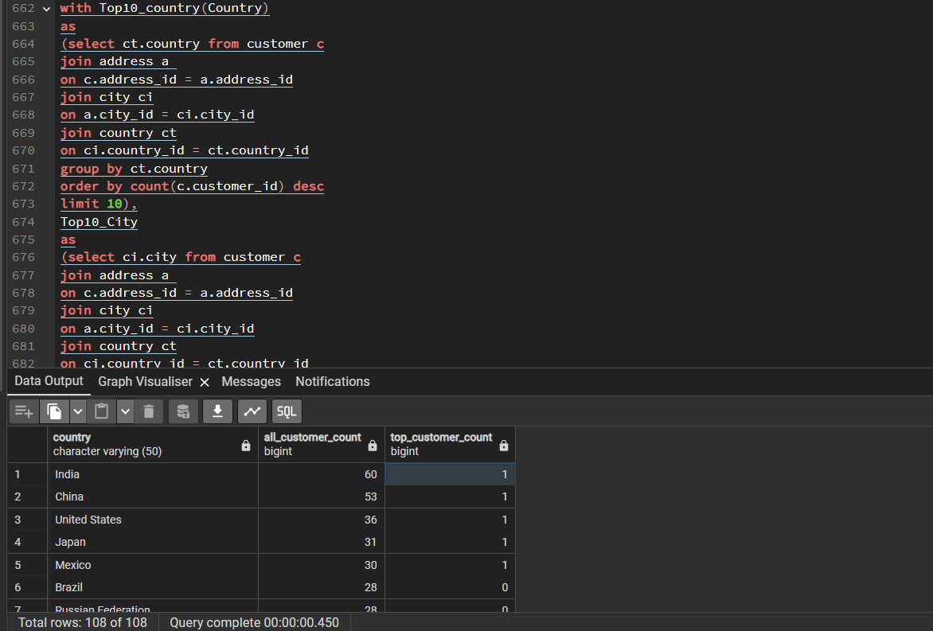

Step 2

I think the CTE queries will perform better than the subqueries. A CTE only has to be defined once, while with a subquery you have to define it every time referring to it and this is why a subquery also often is longer with more lines.

**Comparing costs:**

Query 1 task 3.8:"Aggregate (cost=167.66..167.67 rows=1 width=32)" 84msec

Query 2 task 3.8: "Sort (cost=271.93..272.20 rows=109 width=25)" 80msec

Query 1 task 3.9: Aggregate (cost=729.14..729.15 rows=1 width=32) 92msec

Query 2 task 3.9: Sort (cost=271.80..272.08 rows=109 width=25) 105msec

The results surprised me a bit, but after reading the comparisons between CTE’s and subqueries again I understand more that one does not always perform better than the other. And that it is better to always check this.

Step 3

I got easily confused with these queries as they are more complicated than the examples in the exercise before the task. When I start transforming the queries I make mistakes because I am still learning how to use the right format. But once I made the queries correct and read them back, I do understand the logic and I do understand that CTE’s and subqueries are very similar and that it is a matter of having the same details. The difference is with the CTE query I create the CTE immediately, after this comes the inner statement that is the same as the subquery and then the outer statement, which is adapted to link with the CTE.